**Activation**

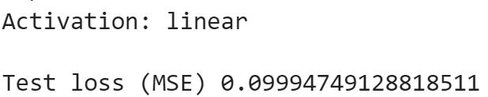 **-> Range ]-inf, +inf[**

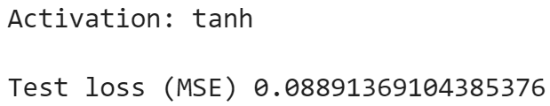 **-> Range [-1, 1]**

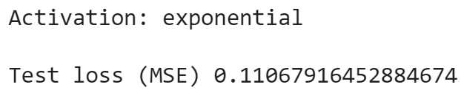

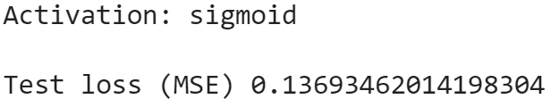

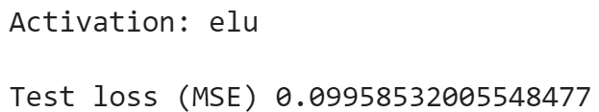

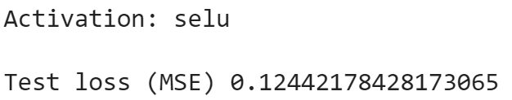

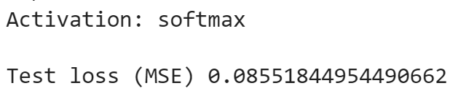

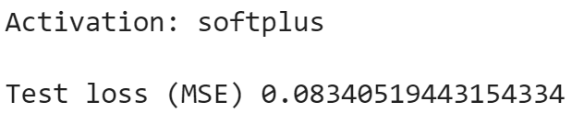

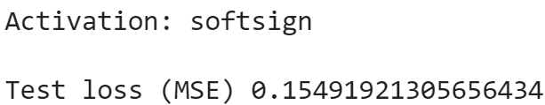

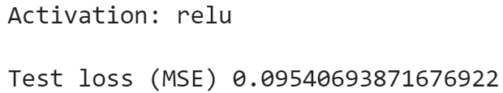

**Loss function (not a good indicator of best choice)**

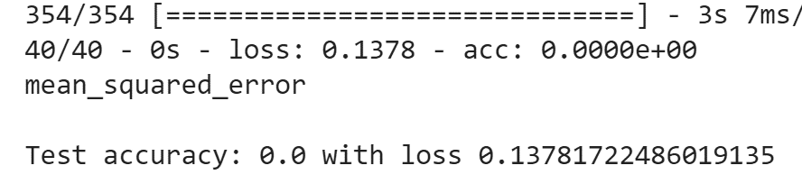

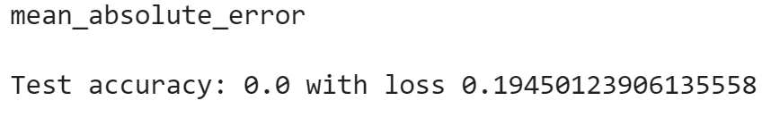

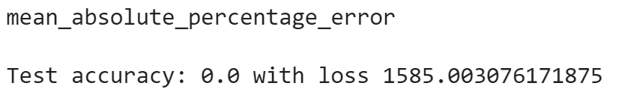

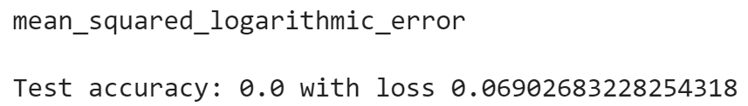

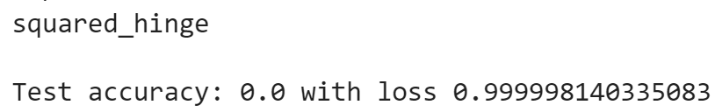

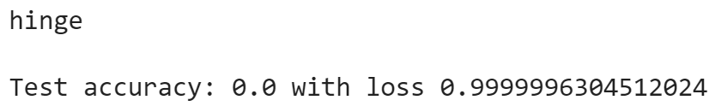

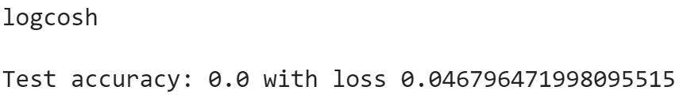

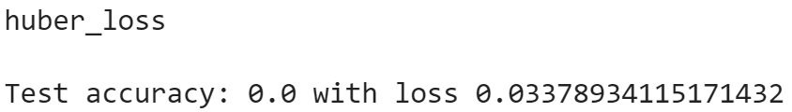

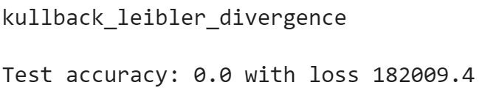

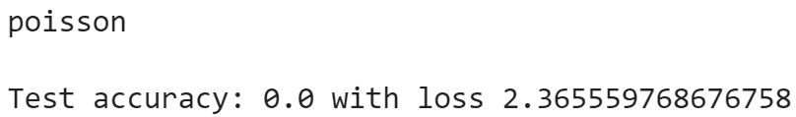

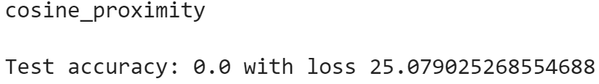

Note: no categorical/binary loss functions because we work in the range [-1, 1]

Mean_squared_error was used to minimize the error and punish worse values more.